Access information for the Hytte

“Access for all" is at the heart of our business
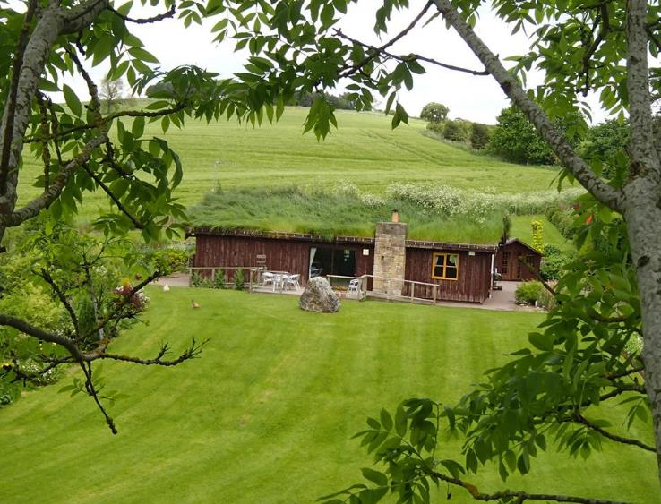

thehytte.com

Key Access features of the Hytte

- Step free access throughout
- Easily accessible kitchen
- Level entry shower
- Height adjustable profiling beds
- Rise and recline chair
- Hoist available

The Hytte was designed from the out set as a great "get together" venue for families and friends and has been adapted to meet the needs of guests with disabilities, ensuring all family members and friends can enjoy a holiday together. Everyone is welcome at the Hytte.
Guests can be assured of our commitment to Access for All as we have been assessed as achieving the standards for either independent wheelchair users or assisted wheelchair users and fulfils additional, more demanding requirements providing for several levels of mobility impairment (With reference to the British Standard BS 8300:2001)
We have received Regional and National Tourism Awards in recognition of our commitment to “Access for All”.

Pre-Arrival
- Groceries can be pre ordered from ASDA, Waitrose, Sainsbury or Tesco’s online.
- Tea, coffee, milk, biscuits and a basket of homegrown free range eggs on arrival.

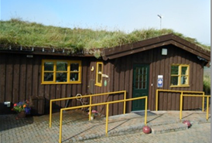
Arrival & Car Parking Facilities
- Guests personally met on arrival, assistance available, and familiarization tour.
- Parking for up to four cars.
- Well lit level paving with wide ramped or stepped access with handrails on both sides.

Main Entrance & porch
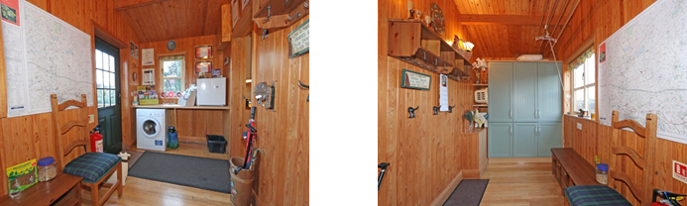
- Entrance door width 860mm, horizontal handle, push opening, hinged door.
- Patio door width 900mm, vertical handle. Sliding doors, flush thresh
- Ground floor level throughout; with open plan living/dining/kitchen area which provides space for wheel chairs to manoeuvre.
- Flooring is wooden throughout, with rugs, which can be, removed.
Where possible all windows have been lowered.
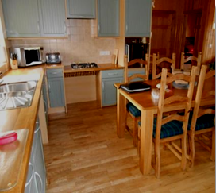
- Washing machine and drying facilities available in the Hytte
- Seating available in this area
- Under counter freezer

Kitchen
- Hob with accessible controls with clear knee access and work surface have been lowered at 85cms/33”
- Sink height 900mm/35” with clear under space for wheelchair access
- Accessible cupboard space at various heights to suit all needs some with carousel shelving.
- Oven base 750mm/30” above floor, side opening door, accessible controls.
- Dining table is 78cms high with 70cms clear space under, can be raised with leg raisers.
- Easy grip angled cutlery, clip on plate surrounds available

The Lounge
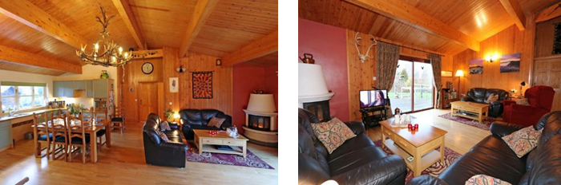
- Seating available includes rise and recline chair 48cms high, sofa and chairs with armrests.
- Smart TV with subtitles.
- Patio door lead out to decking area with table and chairs.

Bedrooms
- All beds are supplied with duvets and two pillows per person (non allergenic) extra pillows and blankets available.
- All bedrooms are furnished with wardrobes that have adjustable hanging and shelf space. Vanity shelf and chair with rigid arms.

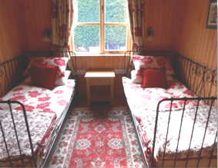
Bedroom 1
- The door opens inward and is 80cm (32”) wide.
- Standard twin bedroom suitable for wheelchair users provides 1200mm / 48” turning space and unobstructed transfer space to bed on left or right side of 900mm/ 36”.
- The bed height is 17”- 43cms from the floor, space under the bed is 22cms 81/2”.
- A chair with armrests is available along with a vanity shelf at 75cm high and wall mirror.

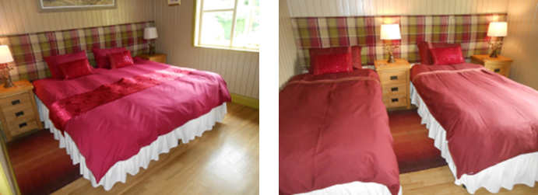
Bedroom 2

- The door opens inward and is 80cm (32”) wide.
- Offers the choice of twin or king size electric beds 560mm/22”high (suitable for a wheelchair user as a twin) provides 1500mm/60” turning space and room for carer or mobile hoist, with clear left or right transfer space, suitable for persons up to 20 stone).
- The beds can be configured as either a king size or twin beds.
- The bed height is 22” 56cms from the floor, space under the bed is 7” 18cms.
- A chair with armrests is available along with a vanity shelf at 75cm high and wall mirror.

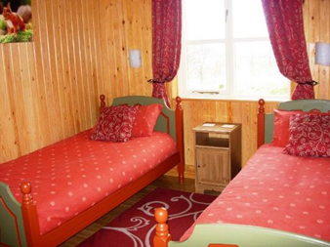
Bedroom 3
- The door opens inward and is 80cm (32”) wide.
- Standard twin bedroom suitable for independent wheelchair users provides 1200mm turning space and unobstructed transfer space to bed on left or right side of 900mm.
- The bed height is 19” 48cms from the floor, space under the bed is 8” 21cms.
- A chair with armrests is available along with a vanity shelf at 75cm high and wall mirror.

Bedroom 4 Accessible room
- (larger) twin room has height adjustable profiling beds with cot sides (suitable for persons up to 25 stones 160kg).
- Height of beds 22”-38” or 56-97cms.
- 1500mm turning space, clear left or right transfer space and room for carers or mobile hoist.
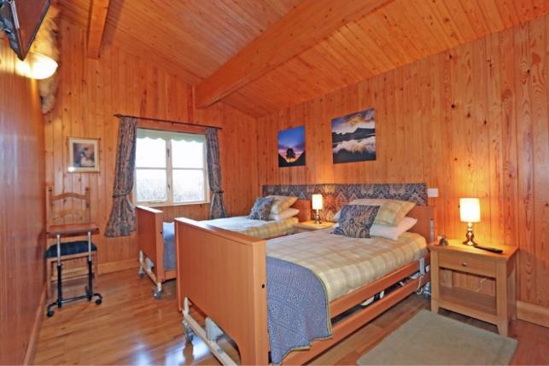
- TV/DVD and touch lamps.
- Mobile electric hoist available (suitable for persons up to 21 stone – 130kg).
- All beds are supplied with duvets and two pillows per person (non allergenic) extra pillows and blankets available.
- All bedrooms are furnished with wardrobes that have adjustable hanging and shelf space. Vanity shelf and chair with rigid arms.
- Commode, over bed table and V shaped support pillow available.
- 4” leg raisers and lifting (monkey) pole available.

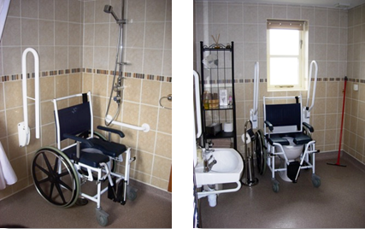
Shower-room & WC
- Door width 800mm.
- Shower room is adjacent to bedrooms.
- Accessible level entry shower room, with support rails, shower chair and self-propelled shower wheelchair.
- which (can be used over the toilet and is suitable for persons up to 25 stone).
- 1500mm turning space, adequate room for carer or mobile hoist.
- Thermostatically controlled shower with adjustable shower head level controls and height.
- Raised toilet at 49cms high right and left hand transfer, touch button flush. Vertical rails available on both sides.
- Lowered hand basin 74cms with lever taps and clear under space and vertical support rails on both sides.

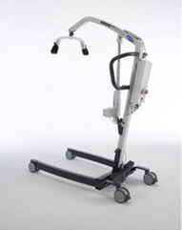
Mobile hoist
- We have an Invacare Birdie hoist.
- Weight limit 150kg or 23 stones.
- Lifting range 53cms to 259cms.
- Guests are advised to bring their own slings (two are available).

Bathroom
- Shower over bath.
- Lever taps on bath and hand basin.
- Standard toilet, lever flush.
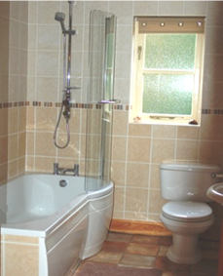
- Contrasting decoration.

Floor plan
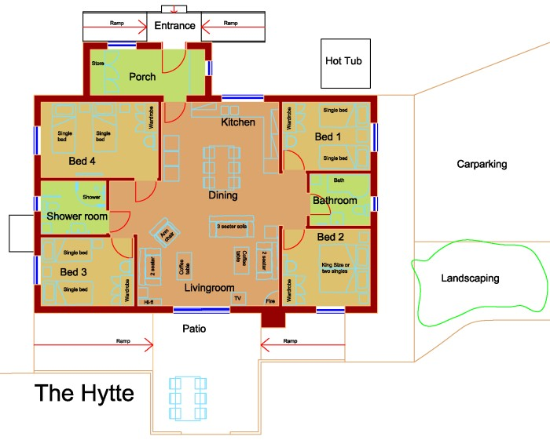

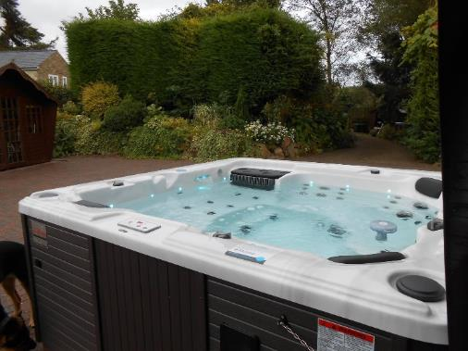
Leisure Facilities
- Hot-tub is accessible via two steps or mobile hoist (supplied, we recommend guests bring their own slings).
- Sauna not wheelchair accessible (however more agile wheelchair users have accessed the sauna, assistance available).

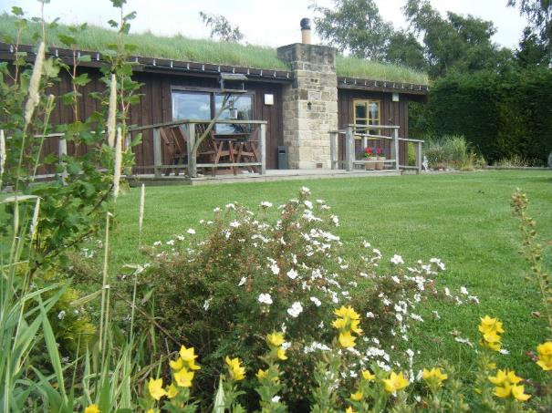
Outdoor Facilities
- Set in over one acre of its own grounds, most of the gardens and grounds are accessible.
- Wheelchair accessible garden furniture.
- Decked verandah, play field and football goal.
- Wildlife area and raised flowerbeds, scented and tactile plants.
- Level paving right round the house, adequate lighting.

Additional Information
We welcome registered Assistance dogs
Local vet - Westway Vets, Corbridge 01434 632033

Local Doctors A&E
Corbridge Health Centre 01434 632011
GP out of hours Service 111 or 999 in an emergency
Hexham General Hospital 0344 811 8111

Staff Training
Sonja is a retired nurse/Midwife
Simon has completed the British Red Cross, Emergency first Aid at Work course
We are always happy to assist if any emergencies arise.

Clinical Waste
We have a separate bin for the disposal of clinical waste

Local equipment hire companies
Bewick Mobility, local electric wheelchair and mobility scooter repairs and hire.
0191 4140240 www.bewickmobility.co.uk

Accessible Taxi’s
EcoCabs 01434 600600

Future Plans
We welcome your feedback on this access statement as well as our service and facilities to help us continuously improve the experience for our guests.

If you have any comments please contact us thehytte@gmail.com

